Created ec2 instance using Ansible

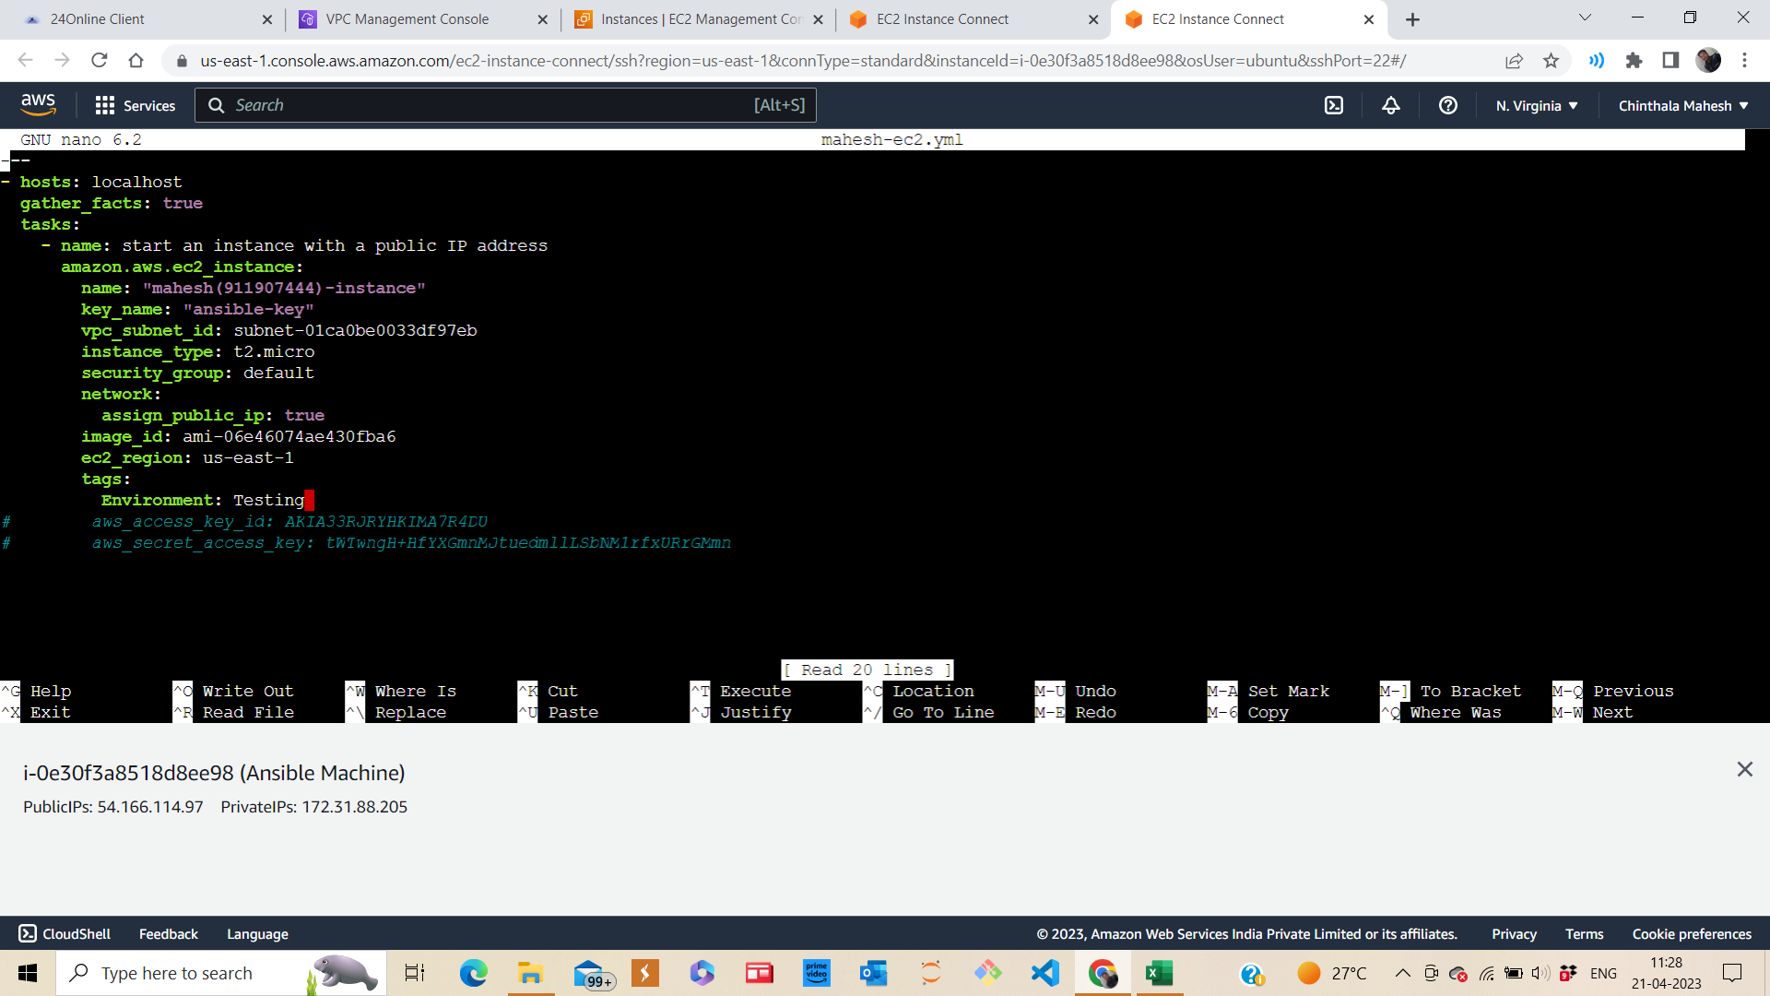

This is the yml file I have created.

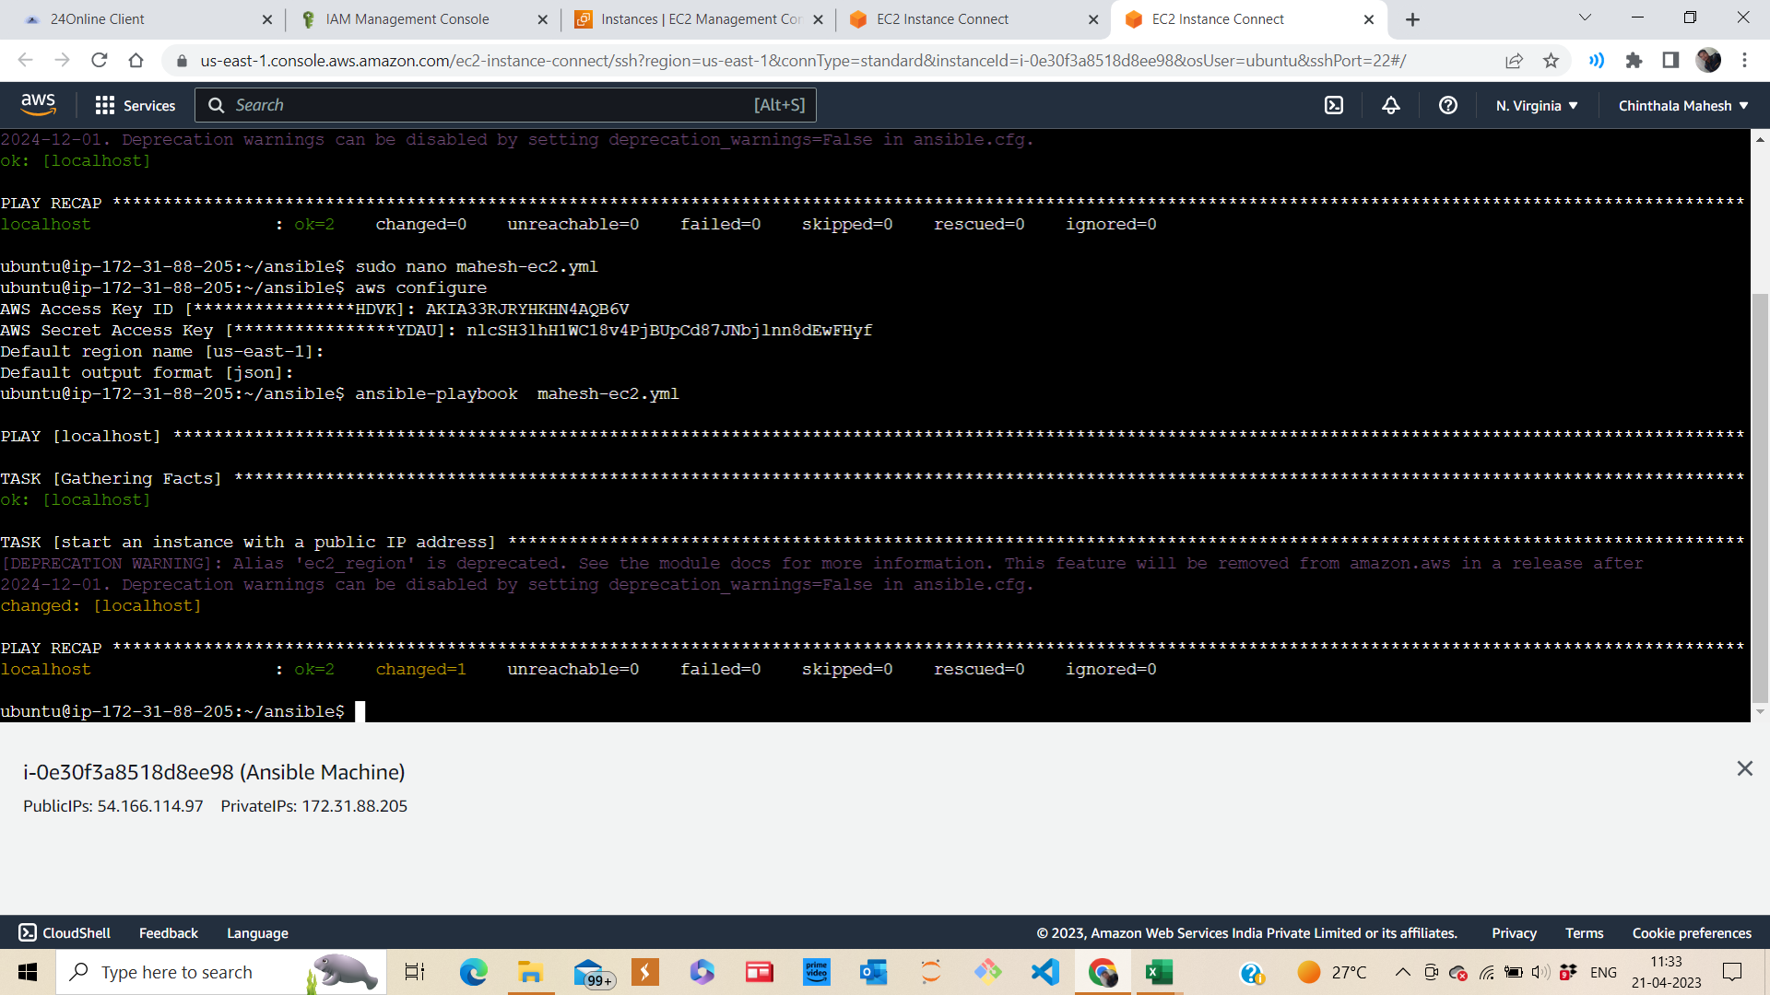

Ec2 instance is created.

Above are the details about the ec2 instance which is created using ansible playbook.